**→ Anomaly Detection :**

**(1) Read our dataset :**

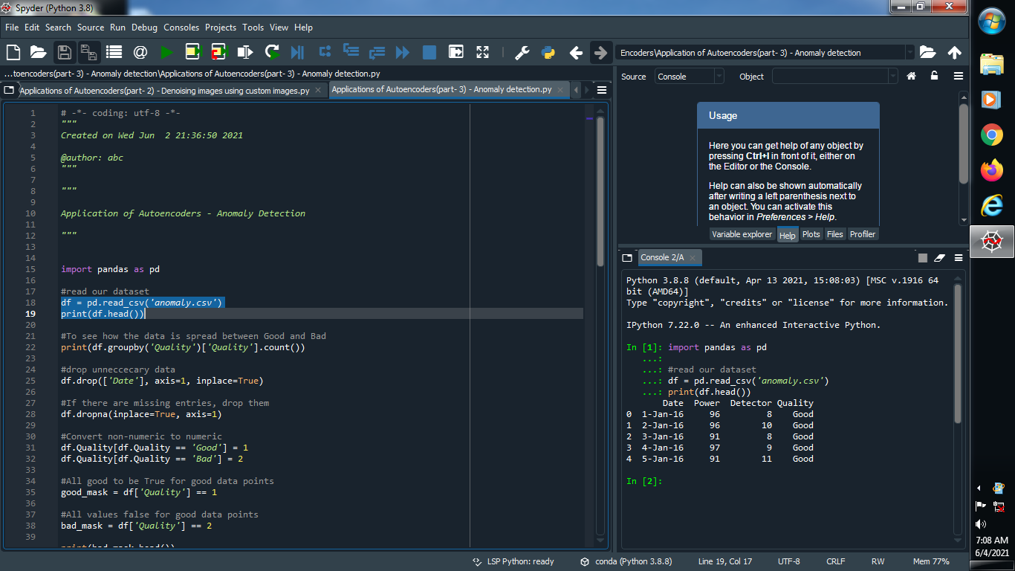

**Output :**



**(2) To see how the data is spread between Good and Bad :**

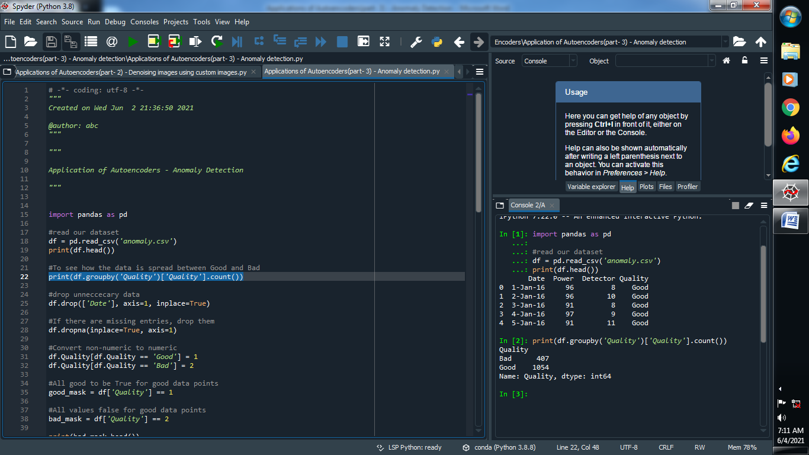

**Output :**



**(3) Drop unnecessary data and fill missing value :**

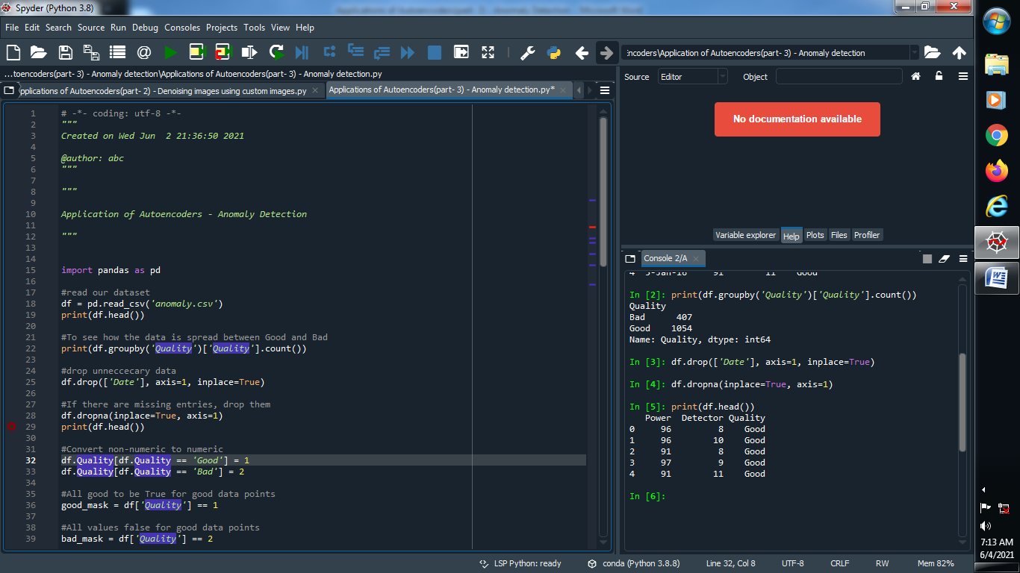

**Output :**



**(4) Convert Non-numeric value into numeric value :**



**Output :**



**(5) Define good value for true and bad value for false :**

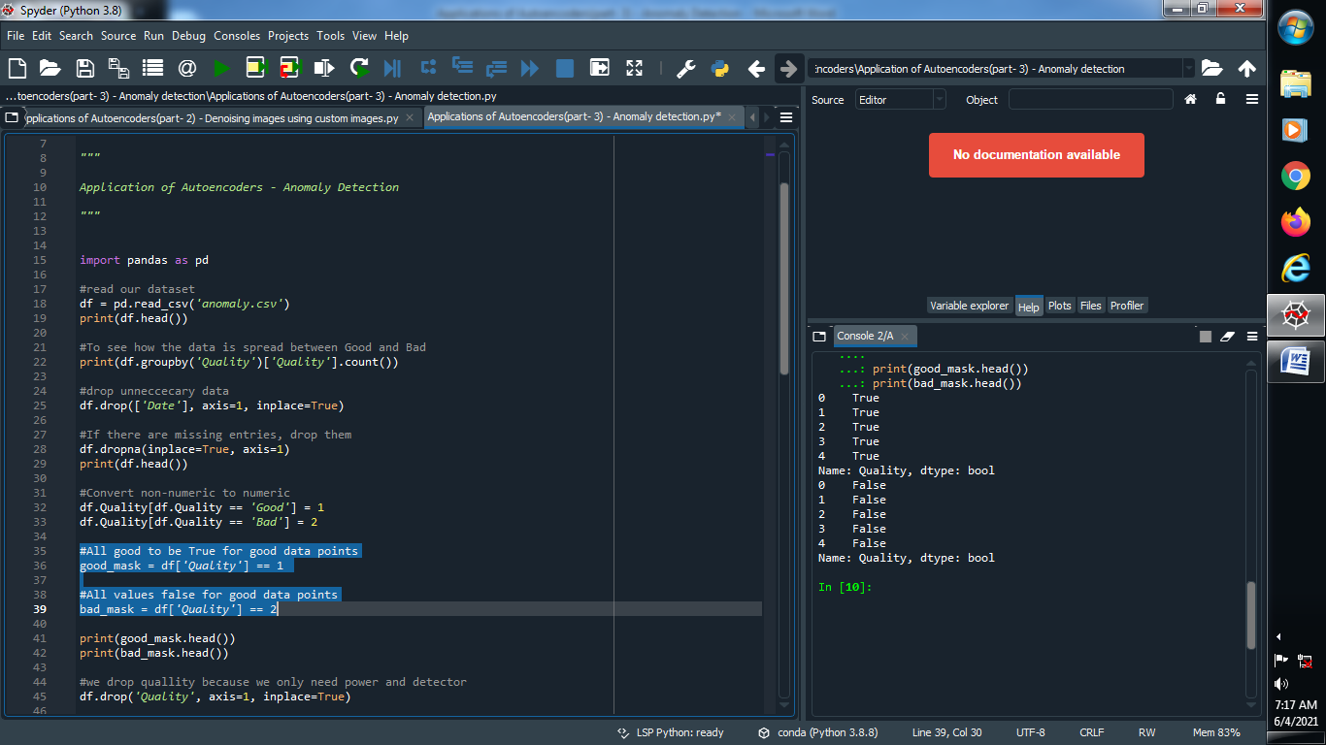

**Output :**



**(6) we drop quality because we only need power and detector :**

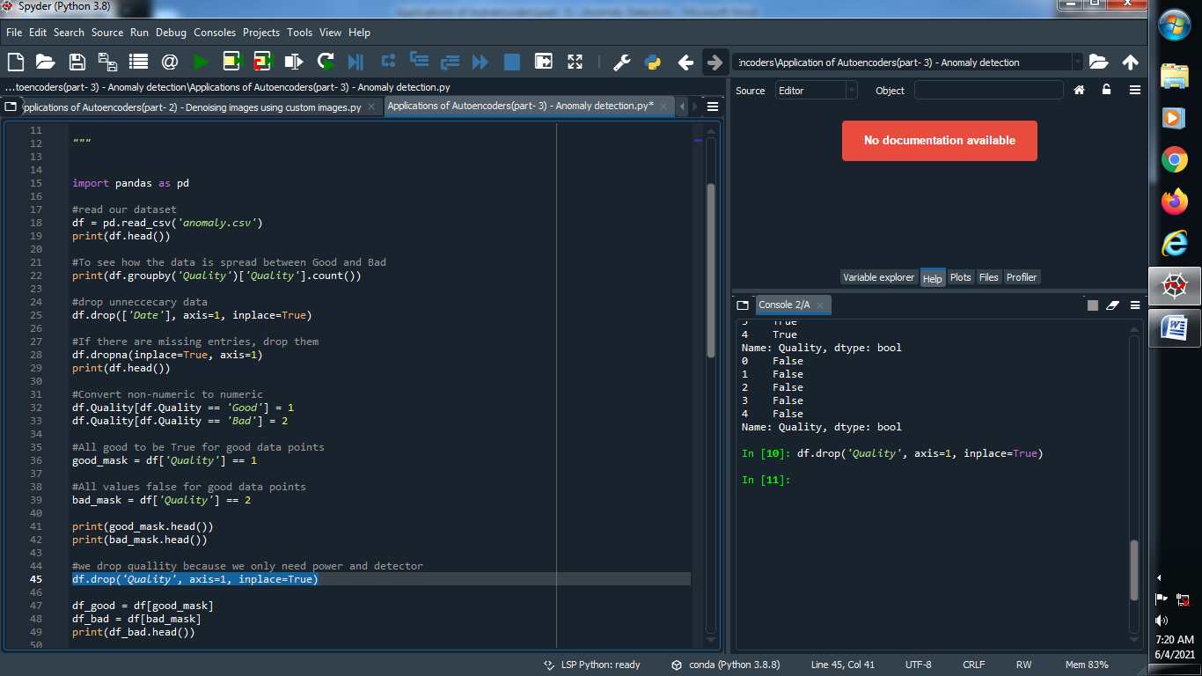

**(7) Define value of good and bad :**

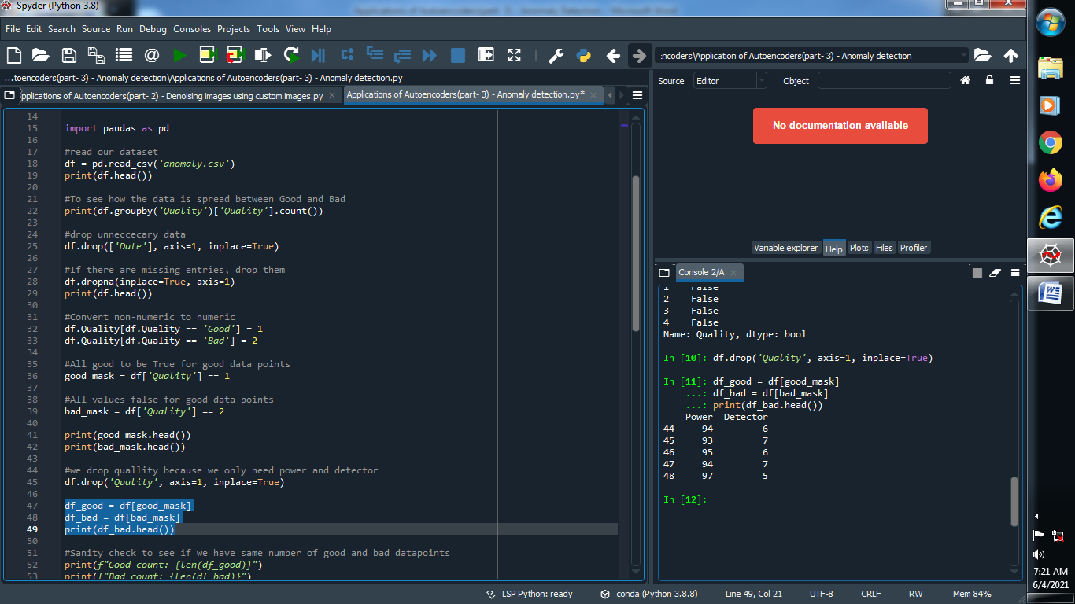

**Output :**



**(8) Sanity check to see if we have same number of good and bad data points :**

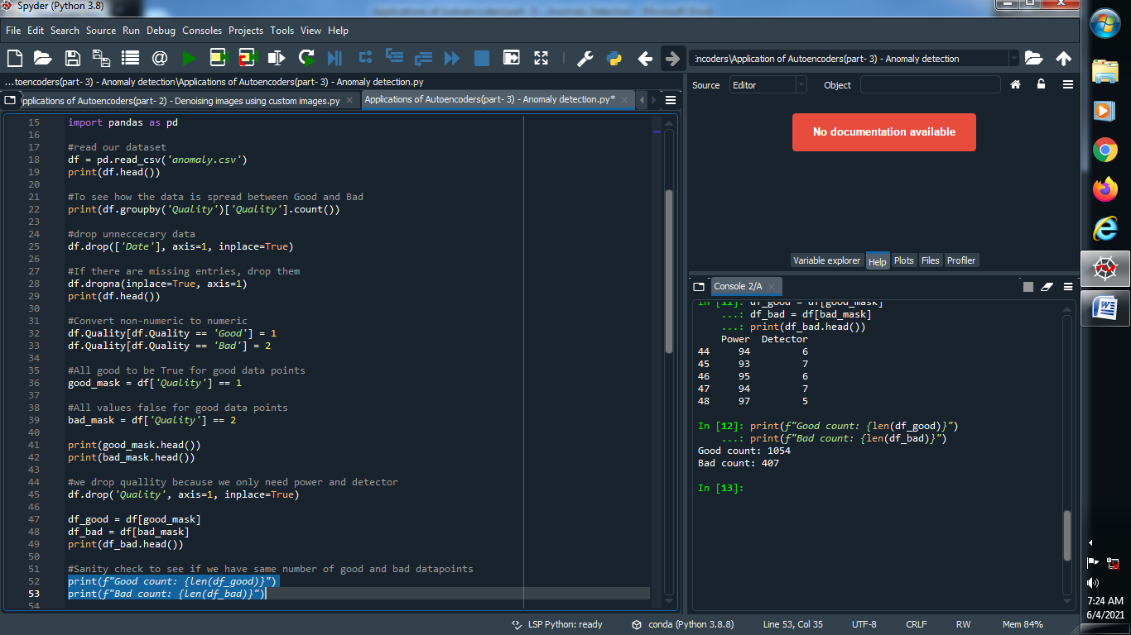

**Output :**



**(9) This is the feature vector that goes to the neural net :**

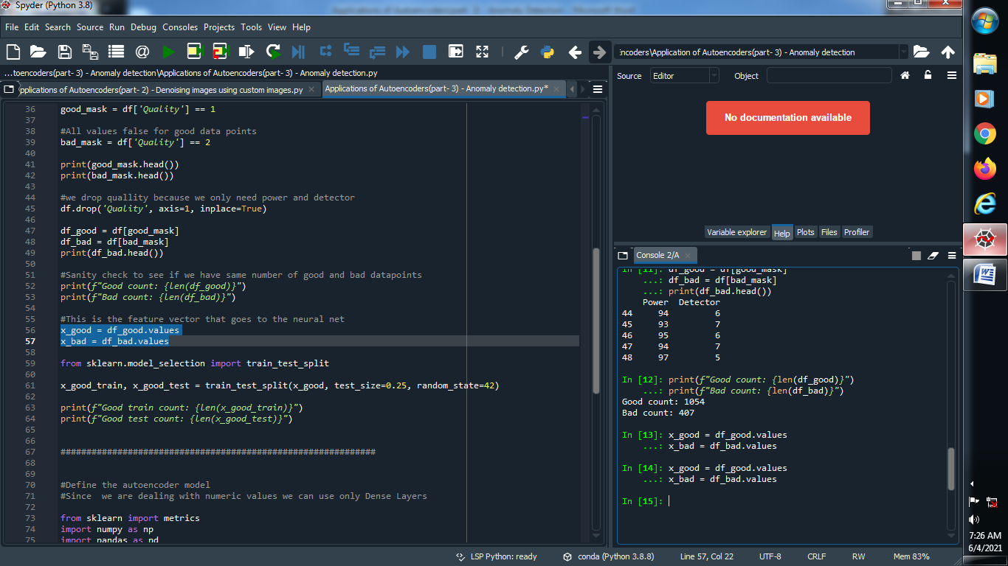

**(10) Find only good values of training and testing :**

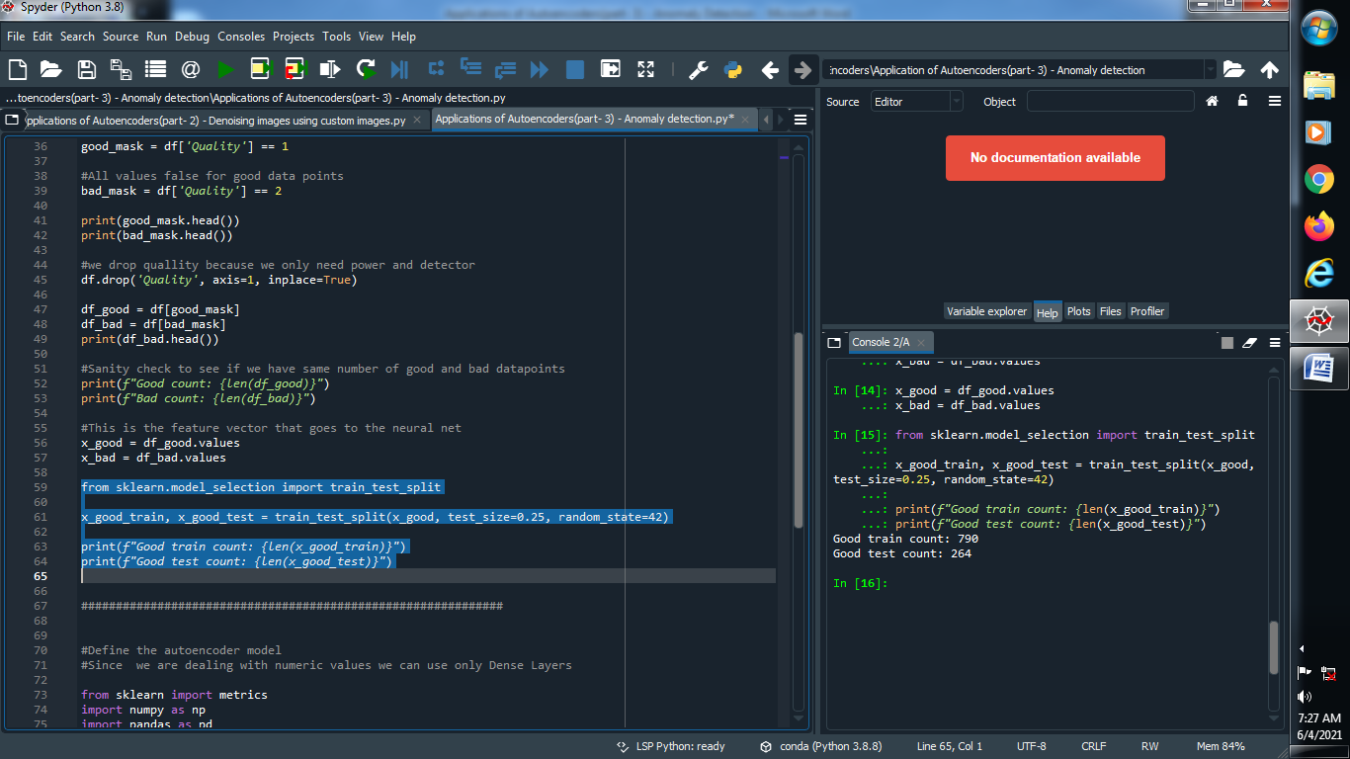

**Output :**



**(11) Define auto encoder model :**

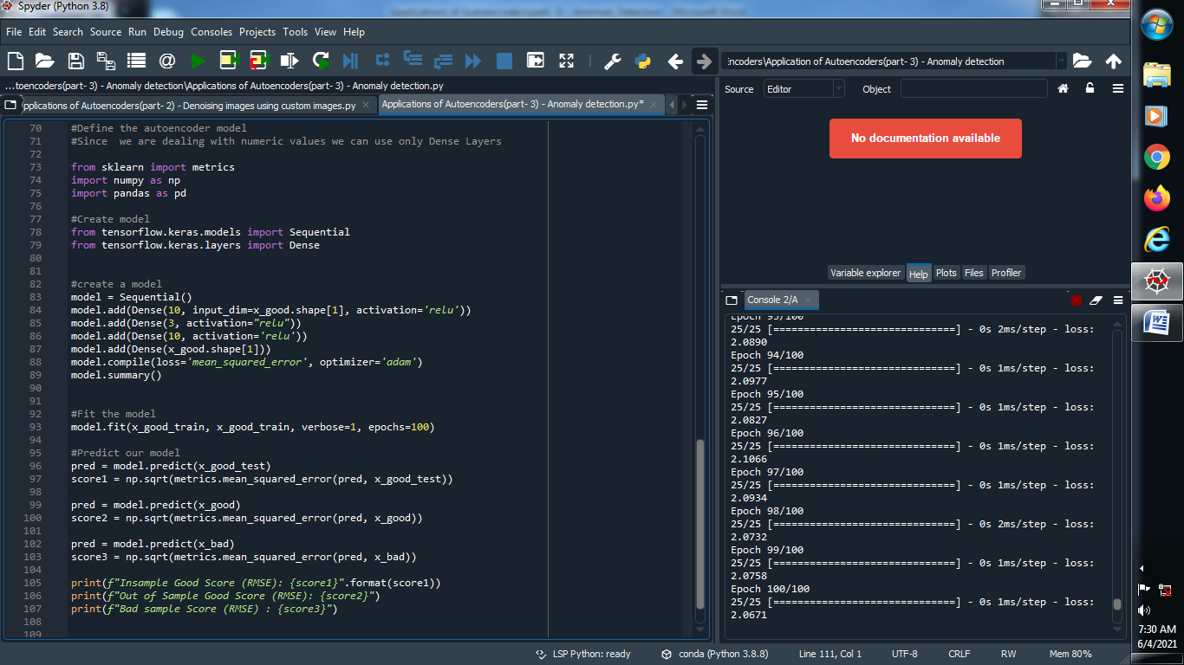

**Output :**

